26.49: a) We wanted a total resistance   from a combination of individual resistors of 
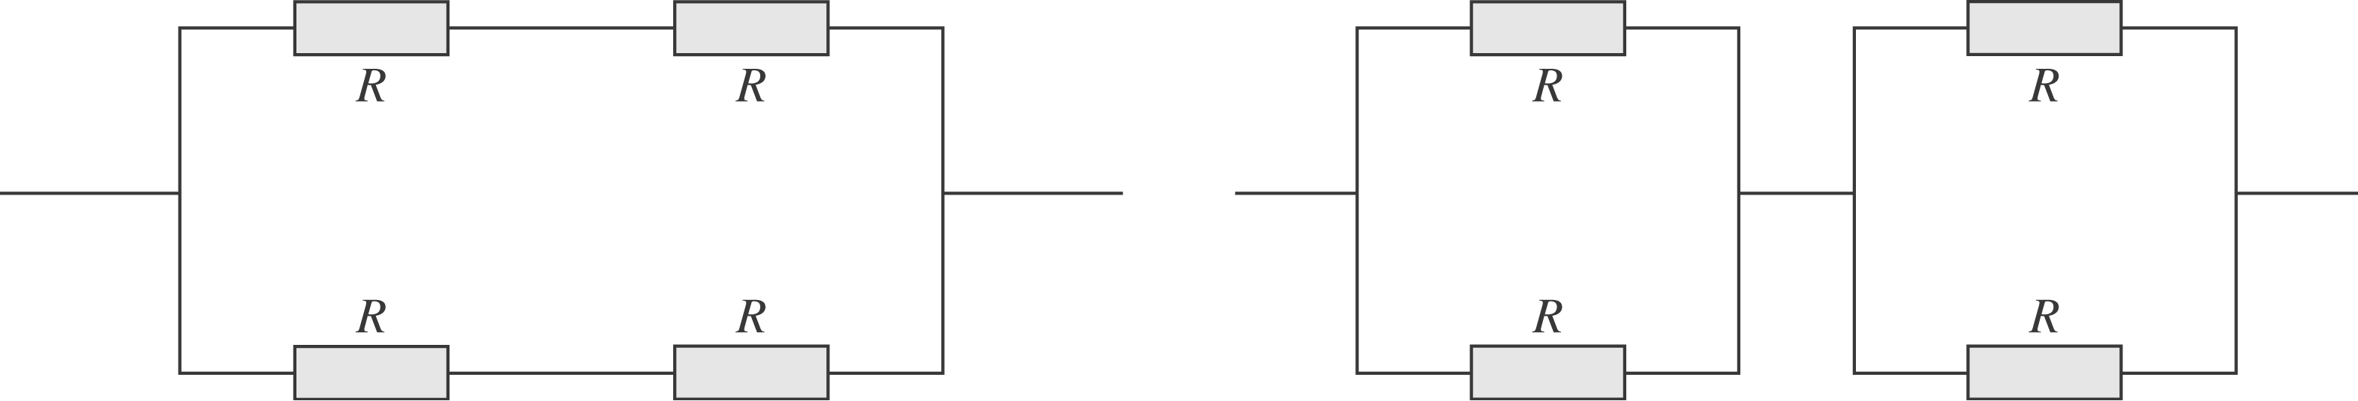
b) The current is given by: each leg half the current flows, so the power in each resistor in each resistor in each combination is the same:

